CLOVIS NORTH
V O L L E Y B A L L
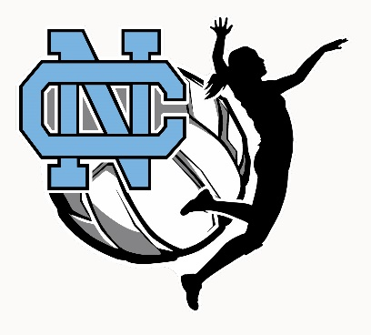
Clovis North Girls Volleyball Program Ad Sales

Securing ads for the program and poster can potentially be one of the most successful ways our program can generate funding. Costs such as extra coaches on staff, equipment and competitive tournaments outside of our local area are just some of the ways we can benefit from our program donations sought out by our players.

To stay competitive in the Valley and beyond!

Attached is a flyer your daughters can bring to local businesses to secure ads – all of the proceeds go towards the program. It is fun and easy and allows our girls to connect with local community members and businesses, building a positive relationship with a wide array of individuals.

Frosh and JV are asked to attempt to sell $300 in ads and Varsity is asked to sell $600 in ads. These are minimum suggestions. If you are able to sell more, the sky is the limit! The more funds generated for our girls, the more opportunities they will have during the season.

There are NO mandatory contributions. If the amount requested is unable to be sold, this will NOT affect playing time or team status.

The deadline for turning in your ad sales is Friday, August 11th. We hope you will utilize this time to contribute to our fundraising efforts. It is our hope that you and your daughter will begin seeking out ad sales now as we move towards this endeavor. Again, ad sales do not ensure a spot on the team nor do they correlate with play time.

Thank you in advance for considering donating to our girls program and for helping to promote our ad sales for our poster and program.

Please turn in completed ad sales form with the check, made out to Girls Volleyball, stapled to the form to Coach Herb. Also, please make sure that all artwork is emailed to me at the address below, or if it is a hard copy, please make sure it is good quality that can be scanned.

If you have any questions, please contact me at travisherb@cusd.com .

